Write a C program to simulate:
- Bankers’ algorithm for the purpose of deadlock avoidance:
#include <stdio.h>
int main()
{
int n, m, i, j, k;
printf("Enter number of processes: ");
scanf("%d", &n);
printf("Enter number of resource types: ");
scanf("%d", &m);
int allocation[n][m], maximum[n][m], need[n][m];
int available[m], request[m];
printf("\nEnter Allocation Matrix:\n");
for(i = 0; i < n; i++)
{
for(j = 0; j < m; j++)
{
scanf("%d", &allocation[i][j]);
}
}
printf("\nEnter Maximum Matrix:\n");
for(i = 0; i < n; i++)
{
for(j = 0; j < m; j++)
{
scanf("%d", &maximum[i][j]);
}
}
printf("\nEnter Available Resources:\n");
for(i = 0; i < m; i++)
{
scanf("%d", &available[i]);
}
for(i = 0; i < n; i++)
{
for(j = 0; j < m; j++)
{
need[i][j] = maximum[i][j] - allocation[i][j];
}
}
printf("\nNeed Matrix:\n");
for(i = 0; i < n; i++)
{
for(j = 0; j < m; j++)
{
printf("%d ", need[i][j]);
}
printf("\n");
}
int process;
printf("\nEnter process number making request: ");
scanf("%d", &process);
printf("Enter Request Vector:\n");
for(i = 0; i < m; i++)
{
scanf("%d", &request[i]);
}
for(i = 0; i < m; i++)
{
if(request[i] > need[process][i])
{
printf("\nError: Process exceeded maximum claim.\n");
return 0;
}
}
for(i = 0; i < m; i++)
{
if(request[i] > available[i])
{
printf("\nResources not available. Process must wait.\n");
return 0;
}
}
for(i = 0; i < m; i++)
{
available[i] -= request[i];
allocation[process][i] += request[i];
need[process][i] -= request[i];
}
int work[m], finish[n], safeSeq[n];
for(i = 0; i < m; i++)
{
work[i] = available[i];
}
for(i = 0; i < n; i++)
{
finish[i] = 0;
}
int count = 0;
while(count < n)
{
int found = 0;
for(i = 0; i < n; i++)
{
if(finish[i] == 0)
{
int possible = 1;
for(j = 0; j < m; j++)
{
if(need[i][j] > work[j])
{
possible = 0;
break;
}
}
if(possible)
{
for(k = 0; k < m; k++)
{
work[k] += allocation[i][k];
}
safeSeq[count] = i;
count++;
finish[i] = 1;
found = 1;
}
}
}
if(found == 0)
{
break;
}
}
if(count == n)
{
printf("\nSystem is in SAFE state.\n");
printf("Safe Sequence: ");
for(i = 0; i < n; i++)
{
printf("P%d", safeSeq[i]);
if(i != n - 1)
{
printf(" -> ");
}
}
printf("\nRequest can be granted immediately.\n");
}
else
{
printf("\nSystem is NOT in safe state.\n");
printf("Request cannot be granted.\n");
}
return 0;
}

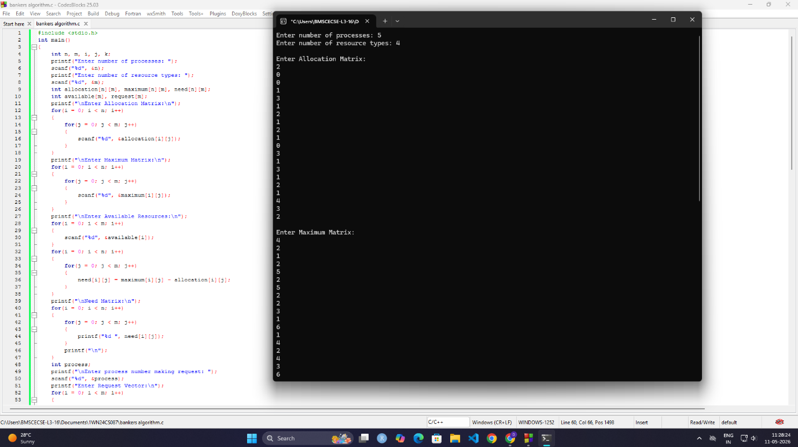

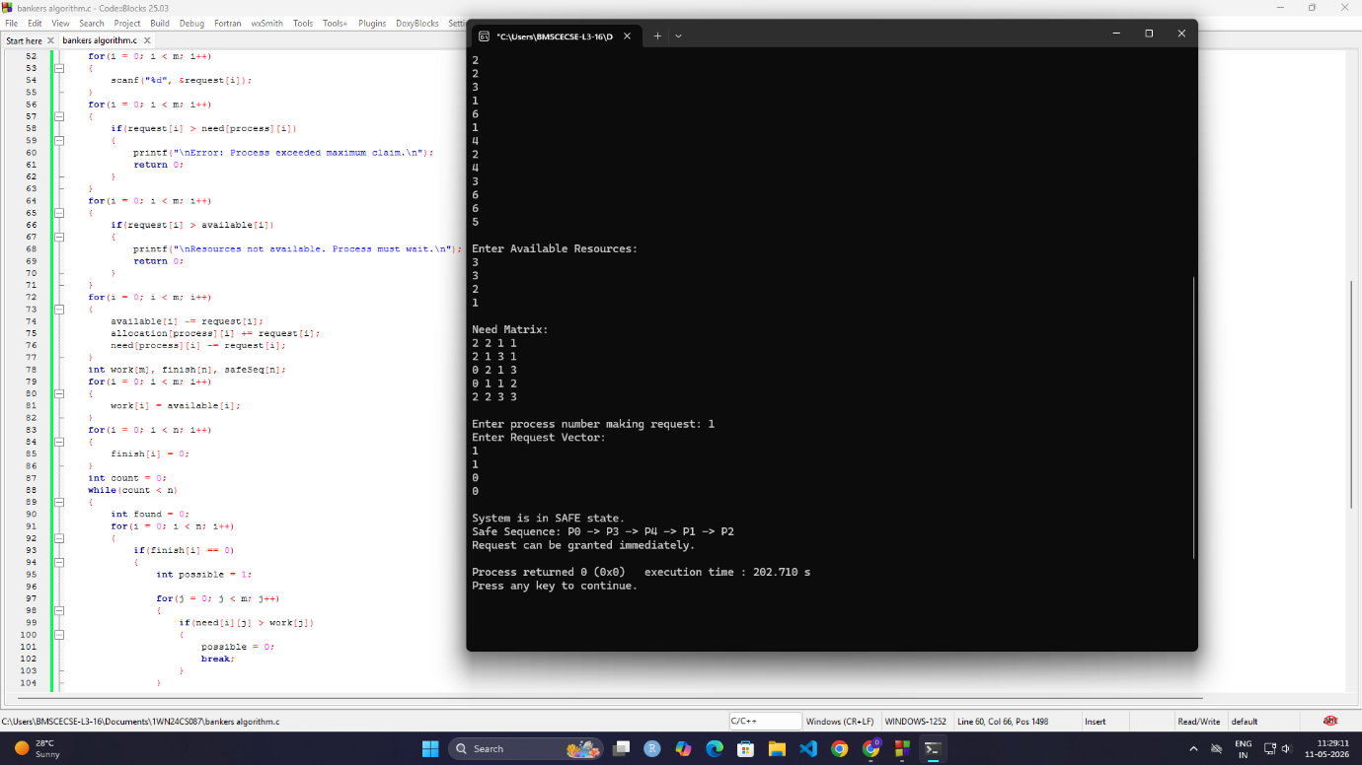

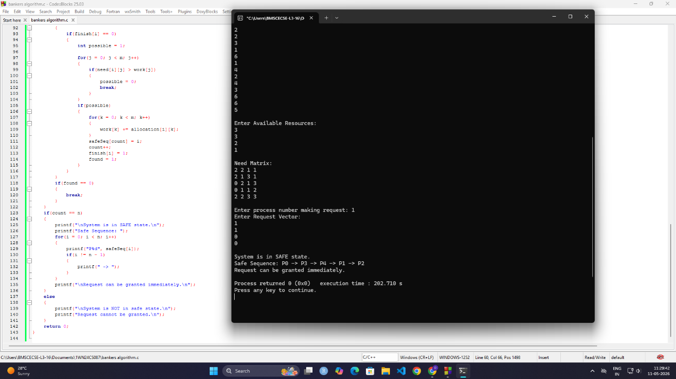

b)Deadlock Detection:
#include <stdio.h>
int main()
{
int n, m, i, j, k;
printf("Enter number of processes: ");
scanf("%d", &n);
printf("Enter number of resource types: ");
scanf("%d", &m);
int allocation[n][m], request[n][m];
int available[m];
printf("\nEnter Allocation Matrix:\n");
for(i = 0; i < n; i++)
{
for(j = 0; j < m; j++)
{
scanf("%d", &allocation[i][j]);
}
}
printf("\nEnter Request Matrix:\n");
for(i = 0; i < n; i++)
{
for(j = 0; j < m; j++)
{
scanf("%d", &request[i][j]);
}
}
printf("\nEnter Available Vector:\n");
for(i = 0; i < m; i++)
{
scanf("%d", &available[i]);
}
int work[m], finish[n];
for(i = 0; i < m; i++)
{
work[i] = available[i];
}
for(i = 0; i < n; i++)
{
int sum = 0;
for(j = 0; j < m; j++)
{
sum += allocation[i][j];
}
if(sum == 0)
finish[i] = 1;
else
finish[i] = 0;
}
int found;
do
{
found = 0;
for(i = 0; i < n; i++)
{
if(finish[i] == 0)
{
int possible = 1;
for(j = 0; j < m; j++)
{
if(request[i][j] > work[j])
{
possible = 0;
break;
}
}
if(possible)
{
for(k = 0; k < m; k++)
{
work[k] += allocation[i][k];
}
finish[i] = 1;
found = 1;
}
}
}
} while(found);
int deadlock = 0;
printf("\n");
for(i = 0; i < n; i++)
{
if(finish[i] == 0)
{
deadlock = 1;
printf("Process P%d is deadlocked.\n", i);
}
}
if(deadlock == 0)
{
printf("No Deadlock Detected.\n");
}
return 0;
}

